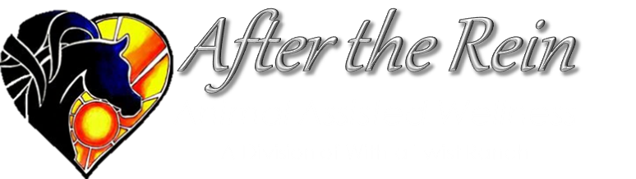
Safety Equipment
Acknowledgement and Release Form

WARNING: THIS AGREEMENT WILL AFFECT YOUR LEGAL RIGHTS. READ IT CAREFULLY!
(For Participants Over the Age of Majority)

Please Print Clearly

Participant's Name:________________ ___________________________ Date of Birth:______ _________

Address:_________ __ __________________________ City____ ____________ Prov.__ __ Postal___
No person riding without a helmet designed for equine activities will be allowed to participate in equine activities
prior to reading and signing this form.
TO: After the Rein Equine Assisted Wellness and With a Twist Ranch,
their directors, employees, (Name of Person, Organization or Company providing the Equine Activities) officers, volunteers, business operators, and site property owners, (all of them collectively called the HOST):

ACKNOWLEDGMENTS AND STATEMENTS OF PARTICIPANT
Initial each item below After Reading and Understanding the item.
_____ 1) I Understand the RISKS inherent in equine activities as evidenced by the separately signed Acknowledgment of Risk and Release of Liability Form on file with the "Host".
_____ 2) I Understand wearing proper safety equipment may reduce injury even though no amount of preplanning can remove all the DANGERS, HAZARDS, and RISKS of equine activities.
_____ 3) I have Freely Decided to ride without wearing a helmet designed for equine activities which might prevent permanent brain damage in the event of an accident.
_____ 4) I have Refused Critical Safety Equipment for equine activities against the advice of the "Host".
_____ 5) I Fully Assume all additional DANGERS, HAZARDS, and RISKS to which my decision to ride without a helmet might expose me.
_____ 6) I Understand that signing this form Waives certain Legal Rights I might have against the “Host”.
Before signing this form I read it (as indicated by my initials above) and I state that I understand it. I further state I am aware that signing this form, waives certain legal rights I and/or my "Legal Representatives" might have against the “HOST”.

SIGNED This _______________________ day of ______________ _______________ , 20____

____________________ ________________
(Signature of Participant)

_______________ _________________________ _______________ _______________________
(Print HOST Name Witness to Signing & Initialing) (Signature of HOST Witness)

